1. First, create a table.

* No. of columns = length of the keyword (number of characters).
* we are not concerned about the number of rows at this point.
* Add the keyword in the first row.

|  |  |  |  |
| --- | --- | --- | --- |
| H | O | M | E |
|  |  |  |  |
|  |  |  |  |
|  |  |  |  |
|  |  |  |  |

1. Then number each column according to the alphabetical order of the letters in the keyword. If the keyword has the same letter 2 times, the first occurrence from left to right gets the priority. (MASS, first “S” will be numbered 3 and second “S” 4).

|  |  |  |  |
| --- | --- | --- | --- |
| H | O | M | E |
| 2 | 4 | 3 | 1 |
|  |  |  |  |
|  |  |  |  |
|  |  |  |  |

1. Count the number of characters in the cypher text and divide it by the number of characters in the keyword(key) to find the number of completely filled rows and partially filled rows.

* TSDWMTASNRS EIEY -> 15 characters
* 15/4 = 3 and remainder 3
* i.e 15 = (4 * 3) + 3
* 3 full rows and 1 row with 3 columns filled

1. Mark the position of the characters in the table. 3 full columns and 1 partially filled column (with 3 characters)

|  |  |  |  |
| --- | --- | --- | --- |
| H | O | M | E |
| 2 | 4 | 3 | 1 |
| x | x | x | x |
| x | x | x | x |
| x | x | x | x |
| x | x | x |  |

1. Fill in the marked positions with the cypher text according to the column number.

* TSDWMTASNRS EIEY

|  |  |  |  |
| --- | --- | --- | --- |
| H | O | M | E |
| 2 | 4 | 3 | 1 |
| x | x | x | T |
| x | x | x | S |
| x | x | x | D |
| x | x | x |  |

|  |  |  |  |
| --- | --- | --- | --- |
| H | O | M | E |
| 2 | 4 | 3 | 1 |
| W | x | x | T |
| M | x | x | S |
| T | x | x | D |
| A | x | x |  |

|  |  |  |  |
| --- | --- | --- | --- |
| H | O | M | E |
| 2 | 4 | 3 | 1 |
| W | x | S | T |
| M | x | N | S |
| T | x | R | D |
| A | x | S |  |

|  |  |  |  |
| --- | --- | --- | --- |
| H | O | M | E |
| 2 | 4 | 3 | 1 |
| W | E | S | T |
| M | I | N | S |
| T | E | R | D |
| A | Y | S |  |

1. Get the plaintext by going from left to right from each row starting from the first.

|  |  |  |  |
| --- | --- | --- | --- |
| H | O | M | E |
| 2 | 4 | 3 | 1 |
| W | E | S | T |
| M | I | N | S |
| T | E | R | D |
| A | Y | S |  |

WESTMINSTERDAYS

1. Separate the characters with spaces as in the cypher text. (Check the capitalization with the given cypher text)

TSDWMTASNRS EIEY

WESTMINSTERDAYS

WESTMINSTER DAYS

## Caesar cipher

The cipher text message “FDQW ZDLW IRU VXPPHU” was encrypted using the Caesar cipher substitution method with a rotation value of (3). The plain text is Blank 1



A B C D E F G H I J K L M N O P Q R S T U V W X Y Z

X Y Z A B C D E F G H I J K L M N O P Q R S T U V W

CANT WAIT FOR SUMMER

Encrypt the message “INFORMATION SECURITY” using the Caesar cipher substitution method and the rotation value of "4". Which cypher text would be the correct one?

A B C D E F G H I J K L M N O P Q R S T U V W X Y Z

W X Y Z A B C D E F G H I J K L M N O P Q R S T U V

MRJSVQEXMSR WIGYVMXC

## SYMMETRIC

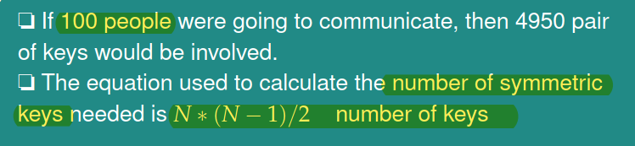

## ASYMMETRIC

